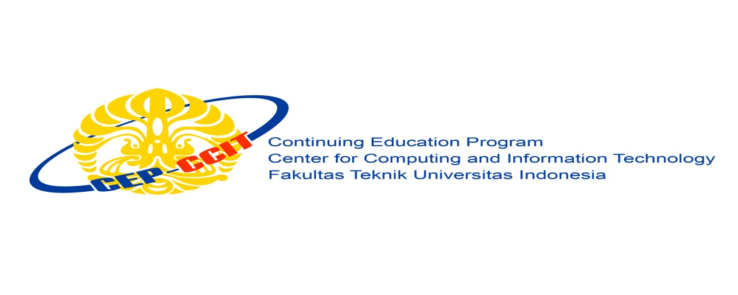

**ISAS**

***Judul ISAS***

Name : *1. Ani*

*2. Budi*

*3. Anto*

Faculty : *Nama Faculty*

Semester : 1

Quarter : 1

Class : 1SC8

Continuing Education Center for Computing and Information Technology Faculty of Engineering, University of Indonesia

2017

**PREFACE**

Praise be to Allah Almighty, Most Merciful, because thanks to His grace and guidance, the writer can arrange and present a paper that contains about deadlock. The writer also thanked to Mr. Tirta Akdi Toma Mesoya Hulu as lecturer Introductory IT courses that have provided guidance to the writer in the process of preparing this paper. Not to forget the writer thank the various parties who have given encouragement and motivation.

The author realizes that in the preparation of this paper there are still many shortcomings and far from perfection. Therefore, the authors expect constructive criticism and suggestions to improve this paper and can be a reference in preparing the papers or subsequent tasks.

The authors also apologize if in writing this paper there are typos and errors that confuse the reader in understanding the author's intent.

**Writer**

**CHAPTER I**

**INTRODUCTION**

**I.1.    Background**

This pragraph yours can explain like, why computer need a operating system, what will happen, if computer without operating system.

This paragraph yours can explain like why system operasi need to update.

This paragraph yours can explain about yours ISAS, example in this paper we wil to expalin about update version to version operating system, advantages and deficiency

**I.2.    Writing Objective**

The following is the purpose of writing a paper entitled "*Title ISAS*":

●  Understand *version to version Bla bla OS*

●  Understand *advantages and deficiency bla bla OS*

●  Understand *the latest user interface Bla Bla OS*

**I.3.    Problem Domain**

This part you can write purpose or goal this paper, like “In this paper can explain about version, advantages and deficiency bla bla OS”

**I.4.**    **Writing Methodology**

This paper is written by studying literature review from various sources, either in the form of material from internet or book.

**I.5.    Writing Framework**

Here is a systematic writing of a paper entitled "Title ISAS".

CHAPTER I INTRODUCTION

●  Background

●  Writing Objective

● Problem Domain

● Writing Methodology

● Writing Framework

CHAPTER II BASIC THEORY

●  Understanding computer

●  Understanding Operating System

●  Understanding User Interface

CHAPTER III PROBLEM ANALYSIS

●  Version Bla Bla OS

●  Advantages and deficiency bla bla OS

●  Explain latest User Interface (UI) Bla Bla OS

CHAPTER IV CONCLUSION AND SUGGESTION

●  Conclusion

●  Suggestion

BIBLIOGRAPHY

APPENDIX

**CHAPTER II**

**BASIC THEORY**

**II.1.   Understanding Computer**

This part you can explain about computer.

**II.2.   Understanding Operating System**

This part you can explain about operating system(OS)

**II.3.   Undersatnding User Interface (UI)**

This part you can explain about User interface (UI)

**II.3.1. First Sub Bab**

Bla bla bla bla bla bla bla bla bla bla bla bla bla bla bla bla bla bla bla bla bla bla bla bla bla bla bla bla bla bla bla bla bla bla bla bla bla bla bla bla bla bla bla bla bla bla bla bla bla bla bla bla bla bla bla bla bla bla bla bla bla bla bla bla bla bla bla bla bla bla bla bla bla bla bla bla bla

**II.3.2. Second Sub Bab**

Bla bla bla bla bla bla bla bla bla bla bla bla bla bla bla bla bla bla bla bla bla bla bla bla bla bla bla bla bla bla bla bla bla bla bla bla bla bla bla bla bla bla bla bla bla bla bla bla bla bla bla bla bla bla bla bla bla bla bla bla bla bla bla bla bla bla bla bla bla bla bla bla bla bla bla bla bla

**CHAPTER III**

**PROBLEM ANALYSIS**

**III.1. Version Bla Bla OS**

Bla bla bla bla bla bla bla bla bla bla bla bla bla bla bla bla bla bla bla bla bla bla bla bla bla bla bla bla bla bla bla bla bla bla bla bla bla bla bla bla bla bla bla bla bla bla bla bla bla bla bla bla bla bla bla bla bla bla bla bla bla bla bla bla bla bla bla bla bla bla bla bla bla bla bla bla bla

**III.1.1. Version 1.0**

Bla bla bla bla bla bla bla bla bla bla bla bla bla bla bla bla bla bla bla bla bla bla bla bla bla bla bla bla bla bla bla bla bla bla bla bla bla bla bla bla bla bla bla bla bla bla bla bla bla bla bla bla bla bla bla bla bla bla bla bla bla bla bla bla bla bla bla bla bla bla bla bla bla bla bla bla bla

**III.1.2. Version 2.0**

Bla bla bla bla bla bla bla bla bla bla bla bla bla bla bla bla bla bla bla bla bla bla bla bla bla bla bla bla bla bla bla bla bla bla bla bla bla bla bla bla bla bla bla bla bla bla bla bla bla bla bla bla bla bla bla bla bla bla bla bla bla bla bla bla bla bla bla bla bla bla bla bla bla bla bla bla bla

**Etc...**

**III.2. Advantages and deficiency bla bla OS**

Bla bla bla bla bla bla bla bla bla bla bla bla bla bla bla bla bla bla bla bla bla bla bla bla bla bla bla bla bla bla bla bla bla bla bla bla bla bla bla bla bla bla bla bla bla bla bla bla bla bla bla bla bla bla bla bla bla bla bla bla bla bla bla bla bla bla bla bla bla bla bla bla bla bla bla bla bla

1. Bla bla
2. Bla bla

**III.3. Explain latest User Interface (UI) Bla Bla OS**

    Bla bla bla bla bla bla bla bla bla bla bla bla bla bla bla bla bla bla bla bla bla bla bla bla bla bla bla bla bla bla bla bla bla bla bla bla bla bla bla bla bla bla bla bla bla bla bla bla bla bla bla bla bla bla bla bla bla bla bla bla bla bla bla bla bla bla bla bla bla bla bla bla bla bla bla bla bla.

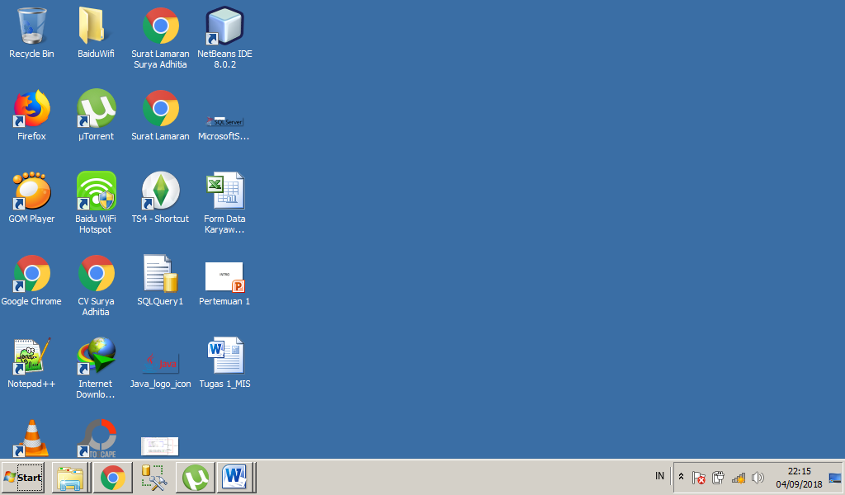

**Figure 3.1 Desktop Bla Bla OS**

Bla bla bla bla bla bla bla bla bla bla bla bla bla bla bla bla bla bla bla bla bla bla bla bla bla bla bla bla bla bla bla bla bla bla bla bla bla bla bla bla bla bla bla bla bla bla bla bla bla bla bla bla bla bla bla bla bla bla bla bla bla bla bla bla bla bla bla bla bla bla bla bla bla bla bla bla bla.

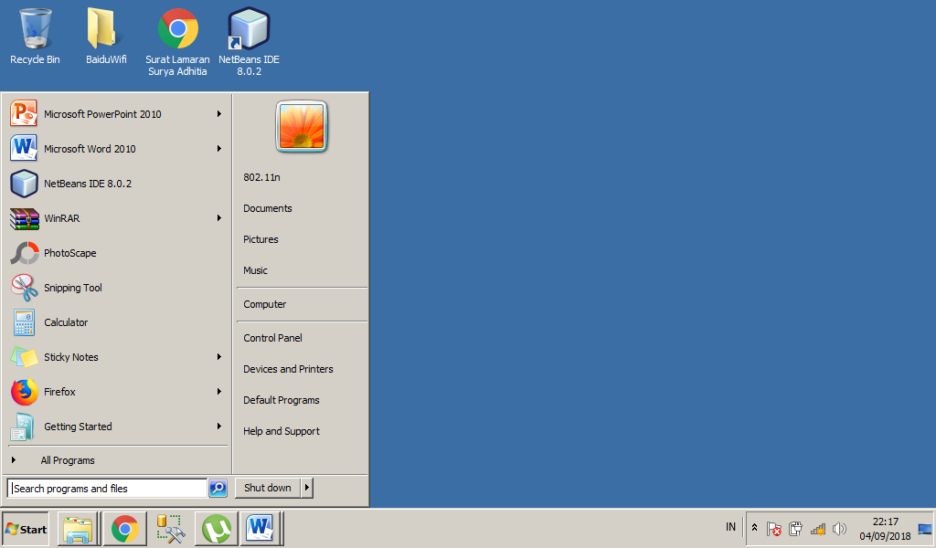

**Figure 3.2 Start Menu Bla Bla OS**

Bla bla bla bla bla bla bla bla bla bla bla bla bla bla bla bla bla bla bla bla bla bla bla bla bla bla bla bla bla bla bla bla bla bla bla bla bla bla bla bla bla bla bla bla bla bla bla bla bla bla bla bla bla bla bla bla bla bla bla bla bla bla bla bla bla bla bla bla bla bla bla bla bla bla bla bla bla.

**CHAPTER IV**

**CONCLUSION**

**IV.1. Conclusion**

Kesimpulan

**IV.2. Suggestion**

Saran

**BIBLIOGRAPHY**

**Fitzsimmons, James A., dan Mona J. Fitzsimmons.** 2006. Service Management: Operations, Strategy, and Information Technology, 5th Edition. New York: McGraw-Hill.

**Achiraeniwati, E., dan R. Aviasti**. 2008. Pengukuran Mutu Layanan Pendidikan Pada Perguruan Tinggi Dengan Menggunakan Student Satisfaction Inventory. Jurnal Teknik Industri Fakultas Teknik Unisba.

**Anggoro, R. Bayu.** 2008. Evaluasi Kualitas Pendidikan Dengan Menggunakan Model Kano (Studi Kasus di Pusat Pendidikan Istibank Pabelan Kartasura). Karya Akhir. Jurusan Teknik Industri Fakultas Teknik Universitas Muhammadiyah Surakarta.